(Affiliated to Mother Teresa Women's University ) Madurai Road,Begambur,Dindigul-624002
We whole-heartedly invites you all for

ORGANIZES A SEMINAR ON
“AN OVERVIEW OF
DECISION MAKING”

CHIEF GUEST
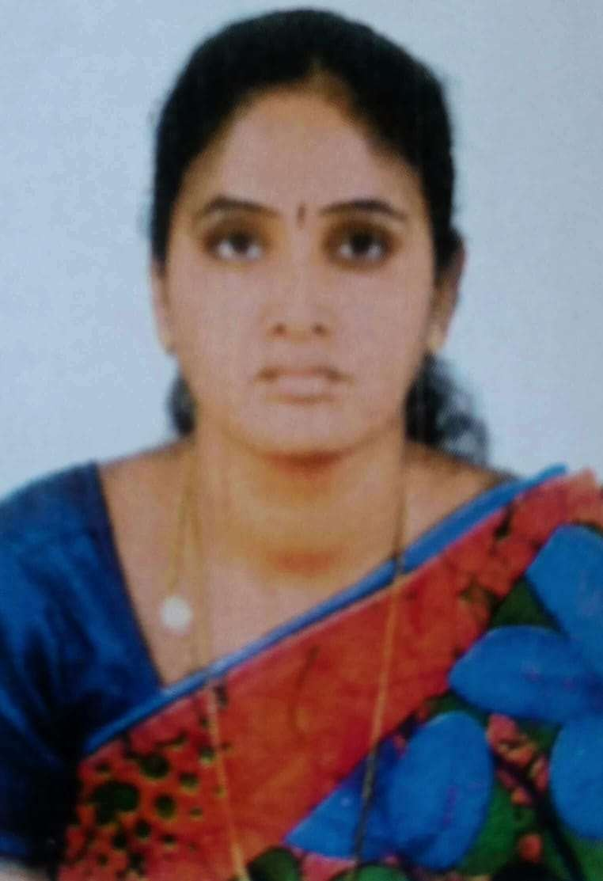
DR.S.KRISHNA PRABHA M.SC., M.Phil., M.E., Ph.D. SET
Assistant Professor of Department of Mathematics PSNA College Of Engg & Tech , DINDIGUL.

BON SECOURS ARTS AND SCIENCE COLLEGE FOR WOMEN
(Affiliated to Mother Teresa Women’s University)
Madurai Road, Begambur (P.O), Dindigul-624002.

A Report on
Seminar-“An Overview of Decision Making”
The Department of Mathematics organized a Seminar on 01.09.2023 at 11.00 a.m. in the auditorium. We have started the function with a Prayer song by choir girls. Mrs. B.Manohari, Head and Assistant Professor of Mathematics, gave the Welcome Address. The Department of Mathematics, Physics and Chemistry students participated in this seminar.
The Chief Guest was Dr. S.Krishna Prabha M.Sc., M.Phil., M.E., Ph.D., SET, Assistant Professor, Department of Mathematics, PSNA College of Engg. & Tech, Dindigul, who was honoured by our Administrator
Rev. Sr. Barthalomeow. The Presidential Address was gave by our Principal, Rev. Sr. Dr.Sirumalar. Then the Chief Guest addressed on the topic of “An Overview of Decision Making”. She gave a talk on Decision Making, and how to apply in our day today life. She also mainly focused on students, how to develop their problem- solving skills. After the valuable speech of our Chief Guest, Our Vice-Principal Rev .Sr. Amali Pushpam gave a Felicitation Address. Finally, Mrs. A.Thenmozhi Assistant Professor, Department of Mathematics, gave the vote of thanks. Then the Seminar was concluded with the college anthem.

